The War Between the Classes
Chapter 2 - 3

- Vocabulary: Write the definition and write your own sentence using the vocabulary words indicated.

Word | Page # | Definition | Sentence
1. sallow | 12
2. tentative | 22
3. etiquette | 29
4. acquaintance | 31
5. sabotage | 32
5. contemptuously | 34
5. chide | 35

- Questions: Complete the following questions in full sentences (except for question 1).

- List the characters that are introduced in the first chapter, write a short description of each character (who they are, what qualities they possess…), and indicate the relationship each has with others in the novel.

Character | Description | Relationships

- Use quotes from the story to show how Amy’s parents feel about Adam and how Adam’s parents feel about Amy. Make sure you explain your answers in detail.

Amy’s parents:
Quotation______________________________________________________________________________________________________________________________________________________________________________
Explanation:____________________________________________________________________________________________________________________________________________________________________________

Adam’s parents:
Quotation:______________________________________________________________________________________________________________________________________________________________________________ Explanation:____________________________________________________________________________________________________________________________________________________________________________

- Identify three examples of prejudice in the story so far.
Example 1:
______________________________________________________________________________________________________________________________________________________________________________________ Explanation:_______________________________________________________________________________________________________________________________________________________________________________________________________________________________________________________________________
Example 2:
______________________________________________________________________________________________________________________________________________________________________________________ Explanation:_______________________________________________________________________________________________________________________________________________________________________________________________________________________________________________________________________

Example 3:
______________________________________________________________________________________________________________________________________________________________________________________ Explanation:_______________________________________________________________________________________________________________________________________________________________________________________________________________________________________________________________________

- Compare Amy and Adam’s parents by filling out the Venn Diagram below. How are the parents similar? How are they different?

_________________ _________________

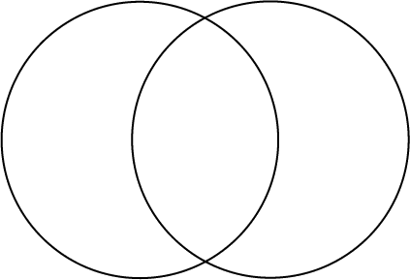

_________________
- What is the color game? Explain.
____________________________________________________________________________________________________________________________________________________________________________________________________________________________________________________________________________________________________________________________________________________________________________

