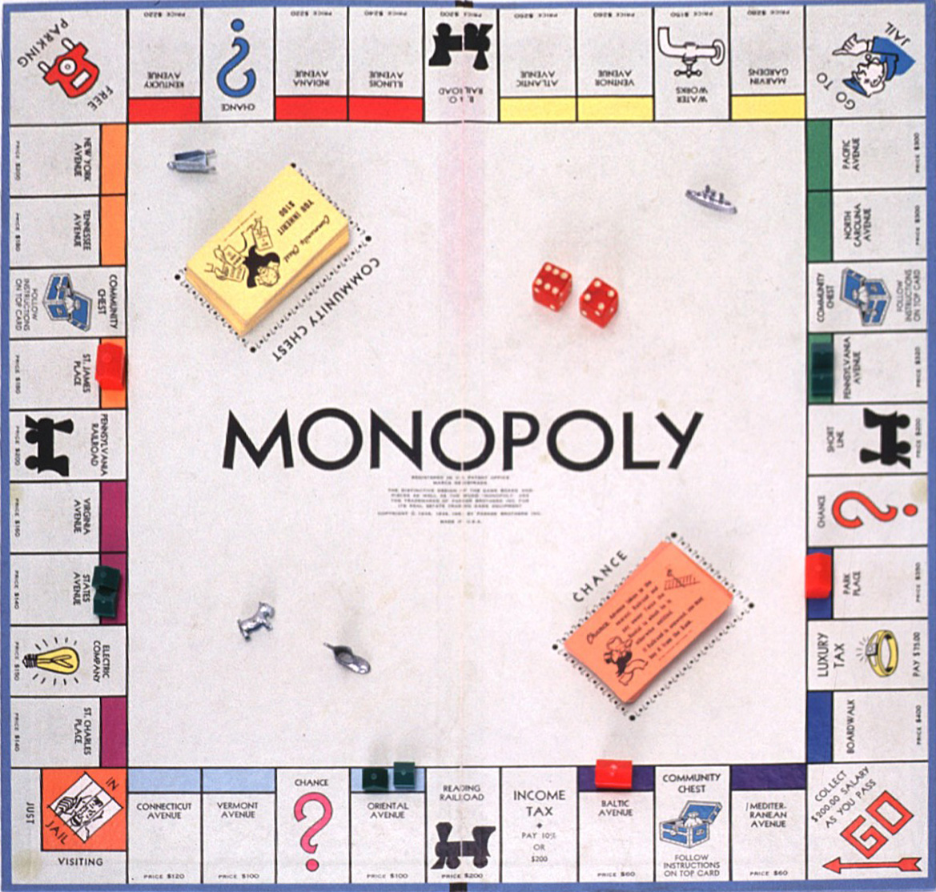
English 8 Board Game Assignment

Directions:
Your group of 2-3 has been chosen by Milton-Bradley game manufacturers to CREATE an educational board game or ADAPT an existing board game to assist high school students in understanding and reviewing the concepts and terminology used throughout the semester.

The publisher wants the following elements incorporated into the game:

- It must be a board game that 5-8 people can play.
- Vocabulary and concepts dealing with the short story, poetry, and novel study units(use your class notes/ handouts as well as the list of examinable terms and include 25).
- Various levels of difficulty should be used to challenge the participant’s knowledge.
- Instructions should be typed and easy to follow.

Each designing group will demonstrate to the class how the game is played and the remainder of the class will be spent playing each others games. You will be asked to provide feedback on the games you play to assist me in my marking.

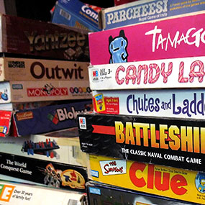
Construction of the game:
- Give your game a name
- You will need to construct a die or a spinner
- The game should last for at least 20 minutes
- Create different options for difficulty
- Game must have a professional look
- Game must have an appealing look
- Game must be APPROPRIATE
- Board map must be placed on the inside of a manila folder or on a board larger than a manila folder
- Board can be hand or computer generated.
- All loose pieces must be placed in a sealed plastic bag
- Be Creative (think outside the box) and HAVE FUN

Tips:
- A variety of printable game boards/game board generators can be found online (you may use these to come up with ideas)
- ***See Rubric for Mark Breakdown
PEER FEEDBACK SHEET

Board Game Assignment

NAME___________________________________ BOARD GAME________________________________

Instructions were clear and easy to understand. (Circle one below that applies)

Disagree Somewhat Disagree N/A Somewhat Agree Agree

All parts of the game were present and worked well. (Circle one below that applies)

YES NO

The game discussed learning terms and or types of information from the course. (Circle one below that applies)

Disagree Somewhat Disagree N/A Somewhat Agree Agree

The board game was fun. (Circle one below that applies)

Disagree Somewhat Disagree N/A Somewhat Agree Agree

The game was challenging but not too difficult. (Circle one below that applies)

Disagree Somewhat Disagree N/A Somewhat Agree Agree

My favorite part of the game was…

I would recommend that the group change this part of the game to make it more fun…

Additional Comments / Suggestions….

____________________________________________________________________________________________________________________________________________________________________________________________________________________________________________________________________________________________________________________________________________________________________________________________________________
English 8 Board Game Rubric

Criteria | Comments | Mark
Knowledge/Understanding:  Knowledge of content is evident in the make up of the game (students cover information from the following areas):  - Demonstrate proper use and understanding of short story and poetry terminology (refer to examinable terminology handout, must include all terms in your game)  - Explore the various subject matter that was covered throughout the course (authors, stories, poems that were examined in class)  - Differentiate the manner in which questions/ course content is presented in the game (ask different types of questions, all questions should not look the same; change it up)  - Be original when creating tasks/ questions, do not present ideas and terminology in the same way they were presented to you in class (this game must be original). |  | /5  /5  /5  /5
Thinking/Inquiry:  Use of critical/creative thinking processes:  - Game is easily understandable yet effectively challenges the class  - Operating instructions are clear and effective - the game runs smoothly |  | /10  /10
Communication  - Communication for difference audiences (game is visually appealing/clearly laid out)  - Use of conventions, vocabulary and terminology in written forms (game board, game pieces and instructions are free from obvious errors). |  | /10  /10
Application:  - Transfer of knowledge and skills to new contexts (student creates a unique and enjoyable game that effectively combines course content with game play). |  | /10

Comments:_________________________________________________________________________________________________________________________________________________________________________________________________________________________________________

